Cyber Security
Unit 1:
Introduction to Cyber security: Defining Cyberspace and Overview of Computer and
Web-technology, Architecture of cyberspace, Communication and web technology,
Internet, World wide web, Advent of internet, Internet infrastructure for data transfer
and governance, Internet society, Regulation of cyberspace, Concept of cyber security,
Issues and challenges of cyber security.

What is Cyber Security?

Cyber Security is the practice of protecting computers, networks, software, and data from unauthorized access, cyberattacks, damage, or theft.
It involves using technologies, processes, and rules to:
- Keep data private (Confidentiality)
- Keep data accurate (Integrity)
- Make systems and data available when needed (Availability)

Security Principles

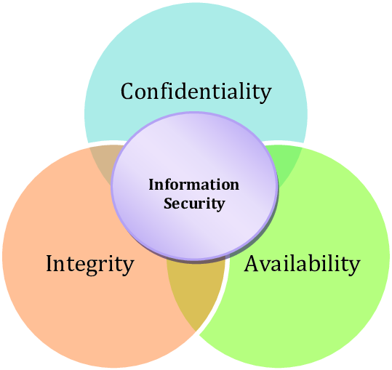

Security Principles :

1. Confidentiality
Definition: Ensures that only authorized individuals can access sensitive information, preventing unauthorized disclosure.
Why it matters: Protects secrets like personal data, financial details, and private communications from being exposed.
How to do it: Use encryption to scramble data, enforce strong passwords and multifactor authentication, and apply strict access controls.
Example: A bank encrypts customer records and requires MFA—so even if a password is stolen, accounts remain protected.

2. Integrity
Definition: Ensures that information remains accurate, complete, and unaltered except by authorized sources.
Why it matters: Prevents unauthorized changes—like tampering with transaction amounts or modifying medical records.
How to do it: Use hashing/checksums to detect changes, digital signatures to verify origin, and access controls or versioning to limit who can modify data.
Example: Software downloads include a checksum that your system verifies—if tampered, the download is blocked.

3. Availability
Definition: Ensures that data and systems are accessible when needed by authorized users.
Why it matters: Keeps critical services—from banking to healthcare—running even during disruptions or attacks.
How to do it: Implement redundancy (backup servers, RAID), use failover and disaster recovery systems, and guard against DDoS attacks and power failures.
Example: An online store uses backup servers and DDoS protection so the site remains accessible during high traffic or attacks.

Why All Three Matter
- Balance is essential:
  - Too much confidentiality (locked-down systems) can restrict legitimate use.
  - Overemphasis on availability can expose sensitive data.
  - Hyper-focus on integrity may over-restrict valid modifications.
- Analogy: A secure house needs good locks (confidentiality), solid walls (integrity), and a dependable, open doorway (availability).

Defining Cyberspace :

Cyberspace is a virtual world [a digital space that exists only in computers] created by the internet and computer networks. It’s where we send emails, visit websites, chat with friends, play games, and store data.
- Interconnected [linked together] devices—like computers, phones, and servers—create this digital space.
- It includes hardware (the physical parts), software (programs), networks (ways devices talk to each other), and people using the internet.
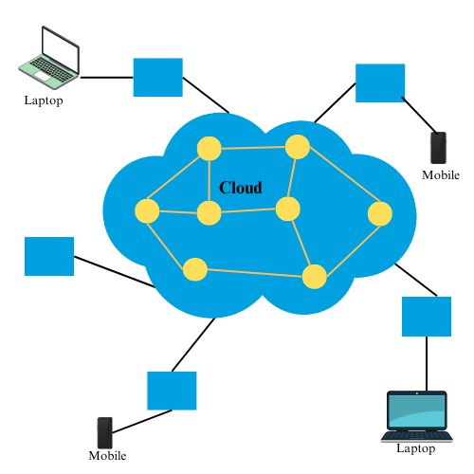

Overview of Computer Technologies

What Is a Computer?
A computer is an electronic machine that takes information (like text, numbers, images), processes it, stores it, and gives back the result as useful output—such as documents, emails, games, or web pages.

Hardware vs. Software
- Hardware: The physical parts you can see or touch—like the CPU (brain of the computer), memory (RAM), storage (hard disk or SSD), keyboard, mouse, and monitor.
- Software: The programs and applications—like Windows, web browsers, and games—that instruct the hardware what to do.

Types of Computers
- Desktop: Stationary computers for home/work
- Laptop: Portable computers
- Tablet/Smartphone: Handheld touch-screen devices
- Server: Powerful computers that share data or run websites
- Embedded devices: Like game consoles, smart TVs, and fitness trackers—all special-purpose computers

1. Hardware
What it is: All the physical parts of a computer you can touch—CPU (the brain), RAM (working memory), storage (where files are kept), and I/O devices (keyboard, mouse, monitor).
Why it's important: These parts make computers run programs, take input, do calculations, and show output.
Example: When you play a game, the CPU processes actions, RAM stores game data briefly, and the monitor displays the images.

2. Software
What it is: Programs and instructions that tell the hardware what to do, including:
- Operating System (OS): like Windows or Android; manages everything running on the computer.
- App Software: like Word, Chrome, or games—designed for specific tasks.
- Programming Languages: like Python or Java—used to create software.
Why it's important: Software transforms raw hardware into useful tools for writing, browsing, and working.
Example: Your OS organizes files and lets Chrome run—you couldn’t browse the web without it.

3. Networking
What it is: The systems and tools that connect computers so they can share data—Internet, Wi-Fi, routers, and cables.
Why it's important: It allows you to browse websites, send emails, and play videos online.
Example: When watching a YouTube video, your device uses the Internet to fetch that video from a server across the world.

4. Data Storage
What it is: Places where information is saved, such as:
- Cloud Storage: like Google Drive—access from any device.
- Databases: organized systems that hold data for apps and websites.
Why it's important: Keeps your files, photos, and records safe and easy to manage.
Example: A school uses a database for students’ grades; you store project files in cloud storage.

5. Emerging Technologies
What it is: The newest and fastest-growing tech:
- AI & ML: computers that learn patterns and make decisions (e.g., voice assistants).
- IoT: everyday devices like fridges or watches connected to the Internet.
- Cloud Computing: using online servers for apps and data instead of your own device.
Why it's important: These are shaping the future—smart homes, self-driving cars, intelligent apps.
Example: Your smartwatch tracks steps, sends info to the cloud, and analyzes your activity using AI.

6. Cybersecurity
What it is: Protecting computers, networks, and data from hackers, viruses, and leaks.
Why it's important: Keeps your information private, reliable, and available when you need it.
Example: Antivirus software and firewalls protect against malware; encryption keeps messages safe.

Web Technology :

1. What Is Web Technology?
Web technology is the collection of tools and rules that make websites and web apps work. This includes designing a page, making it look good, and letting users interact with it.

2. Front-End (Client-Side)
What it is: The part of a website you can see and use in your browser—built with:
- HTML (structure of the page)
- CSS (design and layout)
- JavaScript (adds interactivity and dynamic behaviors)
Example: Clicking a button to show an image slideshow—JavaScript updates the page instantly without refreshing.

3. Back-End (Server-Side)
What it is: The hidden part on the server that handles user requests, processes data, and sends results back.
Common tools: PHP, Python (Django), Node.js, ASP.NET
Example: When you log in to a website, the back-end checks your credentials and returns your profile page.

4. Client–Server Model
How it works:
- Your browser (client) sends a request (e.g., visiting a website).
- The server processes the request and sends back a response (HTML, images, etc.).
- Browser displays the webpage.
This happens using protocols like HTTP/HTTPS
Example: Typing www.example.com → browser makes an HTTP request → server responds with the webpage.

5. Document Object Model (DOM)
What it is: A structure (like a tree) representing the web page’s elements, which JavaScript can change—such as updating text, styling, or reacting to clicks

6. Static vs. Dynamic Pages
- Static pages: Just plain HTML that never changes.
- Dynamic pages: Built using server code (e.g., Python, PHP) and can change based on user actions
Example: A blog where content is generated when someone visits it.

7. Web Best Practices
- Responsive design: Pages adjust to different screen sizes.
- Cross-browser support: Works well on Chrome, Firefox, Safari, etc.
- Separation of concerns: Keep HTML (structure), CSS (style), and JavaScript (behavior) in separate files
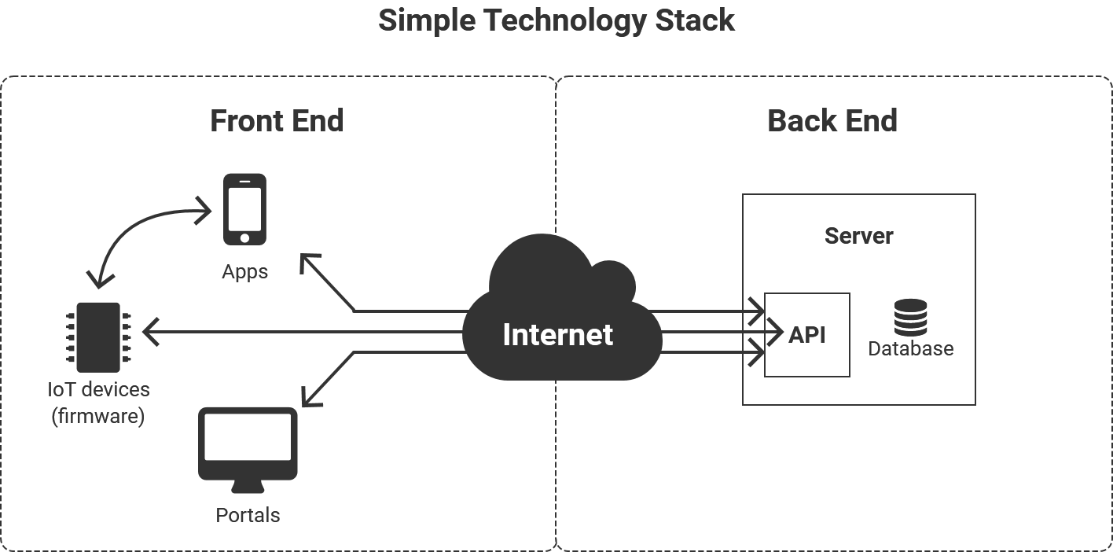
………………………………………………………………

Architecture of Cyberspace
Cyberspace architecture consists of layers and components that work together like parts of a city. Here’s a simplified breakdown:

1. Physical Infrastructure
- What it is: Real, touchable stuff—servers, cables, routers, data centers.
- Why it matters: It’s the base of everything; without it, no data or internet exists.
- Example: Undersea fiber-optic cables and big data centers that power websites.

2. Network Layer
- What it is: Digital “roads” and “traffic rules” (networks and protocols) that guide how data moves.
- Includes:
  - Internet backbone (high-speed global links)
  - ISPs (Internet providers for homes and offices)
  - LANs/WANs (local and wide-area networks)
  - Protocols like IP, TCP, HTTP, and DNS that dictate data transfer.
- Example: Your browser uses HTTP to request a webpage, and DNS to find the right server.

3. Web/Application Layer
- What it is: Where websites, apps, and services run.
- Includes:
  - Web servers that “serve” pages and data
  - Websites/apps you access through browsers
  - Backend technologies (PHP, Node.js, databases) powering user interactions
- Example: Typing youtube.com loads video content served from a web server.

4. Data Layer
- What it is: Places where information is stored and managed.
- Includes:
  - Relational databases (structured tables)
  - NoSQL databases (for flexible or big data)
  - Cloud storage, like Google Drive or AWS S3
- Example: A school’s marks and student data are securely stored in a database.

5. Security Layer
- What it is: The protection layer covering all parts of cyberspace.
- Includes:
  - Firewalls that block dangerous traffic
  - Encryption (e.g., HTTPS) that scrambles data in transit
  - CDNs that speed and secure content delivery
- Example: HTTPS ensures your messages and passwords stay private when logged into a website.

6. User Devices & Interfaces
- What it is: The screens and apps you use to connect to cyberspace.
- Includes:
  - Devices: smartphones, tablets, laptops, desktops
  - UIs & Apps: browsers, email clients, social media apps
- Example: You open your school portal app on a laptop or phone via its interface.

7. Cloud Services & IoT Devices
- What it is: The expanding edge of cyberspace beyond laptops.
- Includes:
  - Cloud platforms (AWS, Azure, Google Cloud) that power apps and store data
  - IoT devices like smartwatches, thermostats, sensors
- Example: Your smartwatch logs fitness data to the cloud, then displays progress in an app.
………………………………………………………………

Communication and Web Technology

1. What is Communication Technology?
Communication technology encompasses the tools and systems that enable the exchange of information between individuals and devices. It includes both hardware (like routers and cables) and software (such as protocols and applications) that facilitate data transmission.

2. Key Components:
- Web-Based Communication:
  - Email: Services like Gmail, Yahoo Mail, and Outlook.com allow users to send and receive emails through web browsers.
  - Instant Messaging: Platforms such as WhatsApp, Facebook Messenger, and Slack support real-time text-based communication.
  - Video Conferencing: Tools like Zoom, Microsoft Teams, and Google Meet enable video and audio communication over the internet.
- Web Development Technologies:
  - Frontend: Languages like HTML, CSS, and JavaScript are used to create the structure, style, and interactivity of web pages.
  - Backend: Server-side languages such as PHP, Node.js, and Python handle the logic and database interactions of web applications.
  - Protocols: HTTP/HTTPS protocols govern the communication between web browsers and servers.

Internet

What is the Internet?
The Internet is a global system of interconnected computer networks that use the Internet Protocol Suite (TCP/IP) to link devices worldwide. It enables the sharing of information, communication, and access to services like the World Wide Web, email, and file sharing.

Internet Architecture
The Internet's architecture is structured in layers, each responsible for specific functions:
- Physical Layer: Includes hardware components like routers, switches, and cables.
- Data Link Layer: Handles data transfer between devices on the same network.
- Network Layer: Manages routing of data packets across networks using IP addresses.
- Transport Layer: Ensures reliable data transfer through protocols like TCP and UDP.
- Application Layer: Facilitates end-user services such as web browsing (HTTP), email (SMTP), and file transfer (FTP).
Each layer communicates with the layers directly above and below it, ensuring data is transmitted efficiently and accurately.
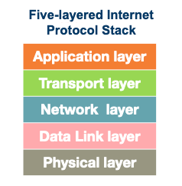
History of the Internet
- 1960s: The concept of an inter-network was proposed by J.C.R. Licklider, envisioning a "Galactic Network" of interconnected computers.
- 1969: The U.S. Department of Defense's ARPANET project successfully connected four university computers, marking the birth of the Internet.
- 1983: The adoption of the Transmission Control Protocol/Internet Protocol (TCP/IP) standardized networking, allowing diverse networks to interconnect.
- 1990s: The World Wide Web, developed by Tim Berners-Lee, made the Internet more accessible to the public.
- 2000s–Present: The Internet has evolved into a platform for social media, e-commerce, cloud computing, and more.

How Does the Internet Work?
The Internet operates on a client-server model:
- Clients: Devices like computers and smartphones that request services or resources.
- Servers: Systems that provide services or resources to clients.
When a client requests a webpage, the request travels through various routers and switches, reaching the appropriate server. The server processes the request and sends the data back to the client.

Importance of the Internet
- Communication: Enables email, instant messaging, and video conferencing.
- Information Access: Provides access to vast amounts of information through search engines and online databases.
- E-Commerce: Facilitates online shopping, banking, and business transactions.
- Education: Offers online courses, tutorials, and resources for learning.
- Entertainment: Streams music, movies, and games to users worldwide.

Security Considerations
With the vast amount of data transmitted over the Internet, security is paramount:
- Encryption: Secures data during transmission, ensuring privacy.
- Firewalls: Monitor and control incoming and outgoing network traffic.
- Antivirus Software: Protects devices from malicious software.
- Secure Protocols: Protocols like HTTPS ensure secure communication between clients and servers.

………………………………………………………………
World Wide Web

What Is the World Wide Web?
The World Wide Web (WWW) is a global system of interlinked documents and resources accessed via the Internet using web browsers. It uses URLs (web addresses), HTTP/HTTPS protocols, and HTML to display content like text, images, and videos.

🔍 How the Web Works (Client-Server Model)
- You enter a URL (e.g., https://www.example.com) in your browser.
- The browser finds the server’s IP using DNS.
- It sends an HTTP request to the server.
- The server responds with HTML, CSS, JS files.
- Your browser renders the page for you to see and interact with.

Why the Web Matters
- Connects billions worldwide for information, shopping, entertainment, learning, and banking.
- Built on hyperlinks, enabling users to move seamlessly between related resources.

A Brief History
- Invented by Tim Berners-Lee at CERN in 1989–1990.
- Publicly popularized in 1993 with the Mosaic browser, making it user-friendly.

……………………………………………………………………………………………………..

Advent of the Internet
(Advent means the arrival or beginning)

1. Early Concepts and ARPANET (1960s)
- The idea started in the 1960s with ARPA (part of the U.S. Department of Defense) to build a robust, distributed network using packet-switching—where data is broken into small packets and sent across different routes.
- In 1969, the first ARPANET connection was made between UCLA and Stanford—marking the birth of today’s Internet.

2. TCP/IP and Network Expansion (1970s–1980s)
- 1974: Vinton Cerf and Bob Kahn introduced TCP/IP, the language that allows different computers and networks to communicate reliably.
- 1983: ARPANET fully adopted TCP/IP—often called the official start of the modern Internet.
- Around the same time, DNS (Domain Name System) was introduced—letting users type google.com instead of remembering numeric IP addresses.

3. NSFNET and Academic Backbone (Mid-1980s–Early 1990s)
- 1986: The national research network NSFNET was launched, connecting universities and supercomputers at speeds up to 56 kbps, later upgraded to 1.5 Mbps and higher.
- 1990: ARPANET was decommissioned as NSFNET became the main backbone—supporting academic research and later commercial use.

4. World Wide Web and Public Access (Late 1980s–1990s)
- 1989–1991: Tim Berners-Lee invented the World Wide Web, introducing HTML, HTTP, URLs, and the first browser—making the Internet user-friendly and accessible globally.
- 1993: The Mosaic browser launched, popularizing graphics and clicking through web pages and marking the start of mass public use.
- Mid-1990s: Commercial websites (Amazon, eBay, Yahoo) and ISPs (like AOL, CompuServe) emerged, leading to the dot-com boom.

5. Commercial Internet and Dot-Com Boom (Late 1990s–2000s)
- ISPs expanded rapidly in the late 1990s, bringing internet to homes worldwide.
- The dot-com bubble saw massive investment in online companies—many failed, but some like Amazon and Google thrived.

6. Modern Internet (2000s–Present)
- Broadband, mobile internet, cloud services, social media, and high-speed wireless (4G/5G) transformed access and usability.
- The Internet became central to daily life—education, business, entertainment, and social networking.

Internet Infrastructure for Data Transfer & Governance

1. Physical Infrastructure
At the core of the Internet’s global connectivity is a physical network consisting of:
- Submarine fiber-optic cables: These undersea cables connect continents and carry over 95% of global intercontinental Internet traffic. They offer massive data capacity and lower latency compared to alternatives like satellites.
- Internet Exchange Points (IXPs): Local hubs where multiple Internet Service Providers (ISPs) and networks interconnect. IXPs allow traffic to be exchanged locally, reducing latency and cost, and improving overall Internet speed and resilience.
- Data centers: Large, secure facilities housing thousands of servers. They host websites, cloud applications, and streaming services 24/7, providing storage, compute power, and reliability.
- Content Delivery Networks (CDNs): Distributed edge servers that cache content geographically close to users. CDNs reduce load times, handle peak traffic efficiently, and improve user experience.
- Internet Service Providers (ISPs): Companies that connect end-users (homes, businesses, mobile devices) to the Internet using fiber, DSL, cable, or cellular technologies. ISPs deploy network infrastructure and participate in policy debates (e.g., net neutrality).

2. Network Backbone & Routing
The Internet’s backbone is a mesh of interconnected high-speed networks managed primarily by Tier-1 ISPs. Routing between these networks uses protocols like BGP (Border Gateway Protocol), which directs traffic across different autonomous systems. Although crucial, BGP can be vulnerable to misconfigurations or attacks that misroute or interrupt traffic.

3. Data Transfer Protocols
Data travels through this infrastructure using standardized protocols that ensure reliable and secure communication:
- TCP/IP (Transmission Control Protocol / Internet Protocol): Breaks data into packets, sends them across networks, and reassembles them reliably at the destination. This suite underpins virtually all Internet communications.
- HTTP / HTTPS: The protocol for web page transfer. HTTPS adds encryption (via TLS) to secure data in transit, protecting privacy and integrity for activities like banking or shopping.
- IPv6: The newest Internet Protocol version, vastly expanding the available IP address space to accommodate the rapidly growing number of Internet-connected devices.
- FTP (File Transfer Protocol): Used for transferring files between computers.
- VPNs (Virtual Private Networks): Encrypt data over public networks, securing sensitive information and ensuring privacy.

4. Governance & Standards
The Internet is coordinated by a multistakeholder ecosystem involving technical experts, companies, governments, and users working collaboratively:
- ICANN (Internet Corporation for Assigned Names and Numbers): Oversees the global namespace for domain names and IP addresses, ensuring unique and stable Internet addressing through a consensus-driven, bottom-up process.
- IETF (Internet Engineering Task Force): Develops and maintains core Internet protocols (TCP, IP, HTTP, SMTP, etc.) through open standards documents known as RFCs.
- W3C (World Wide Web Consortium): Defines open standards for web technologies like HTML, CSS, and XML to ensure compatibility and accessibility worldwide.
- The multistakeholder model avoids centralized government control, promoting an open, global Internet.

5. Policy Issues & Digital Sovereignty
Beyond infrastructure and protocols, governance involves important policy issues:
- Net neutrality: Requires ISPs to treat all Internet traffic equally without blocking or favoring specific content, preserving fair user access.
- Digital divide: The disparity between those with Internet access and those without, which governance efforts try to reduce by expanding broadband and supporting community networks.
- Data protection & privacy: Laws such as the GDPR regulate how personal data is collected, stored, and transferred, influencing technical and operational standards worldwide.
- Digital sovereignty & fragmentation: Some countries push for data localization and national control of Internet infrastructure, risking fragmentation of the global, borderless Internet through national firewalls, routing restrictions, or censorship.

6. Emerging Trends & Challenges
The Internet landscape is evolving rapidly with new technologies and challenges:
- 5G and edge computing: These technologies bring data processing closer to users, reducing latency and enabling applications like real-time VR or remote healthcare. They also require new infrastructure investments and raise governance questions on spectrum and access fairness.
- Internet of Things (IoT): The explosion of connected devices increases data flow and infrastructure needs but introduces security and privacy risks due to more vulnerable endpoints.
- Artificial Intelligence (AI): AI services depend on massive data transfers and computing resources, raising concerns about transparency, bias, and control of data used in AI systems.
- Decentralized technologies: Blockchain and peer-to-peer networks offer more distributed models of Internet services, enhancing user control and security but also challenging existing governance frameworks and interoperability standards.
- Security vulnerabilities & geopolitical tensions: Physical infrastructure (cables, routers) can be targeted by cyberattacks or physical damage. Additionally, geopolitical competition influences control over cable routes and digital resources.

Internet Society (ISOC)
The Internet Society (ISOC) is a global, nonprofit organization dedicated to ensuring the open development, evolution, and use of the Internet for the benefit of all people worldwide.

Key Points About the Internet Society:
- Founded: In 1992 by Internet pioneers to support the growth and accessibility of the Internet.
- Mission: Promote an open, globally connected, trustworthy, and secure Internet.
- Activities:
  - Advocates for Internet policies that promote access and innovation.
  - Supports standards development through partnerships with bodies like the IETF.
  - Provides education, capacity-building, and outreach programs to expand Internet access.
  - Helps communities worldwide build Internet infrastructure and governance capacity.
- Global Reach: Has members, chapters, and partners worldwide working together on Internet issues at local, national, and international levels.
- Focus Areas:
  - Internet governance and policy
  - Security and privacy
  - Open standards and technologies
  - Bridging the digital divide to connect underserved communities
  - Promoting human rights and freedom of expression online

Regulation of Cyberspace

Regulation of Cyberspace refers to the diverse laws, policies, and rules that govern activities in the digital world. These regulations aim to protect users, ensure security, promote fairness, and foster responsible use of the Internet and digital technologies. They vary significantly across countries, reflecting different legal frameworks and priorities.

Key Areas Covered by Regulations in Cyberspace:
- Data Privacy:
Many countries have enacted data protection laws to safeguard individuals' personal information from misuse or unauthorized access. Examples include the EU’s GDPR and California’s CCPA.
- Cybersecurity:
Organizations are required to implement cybersecurity measures to protect their digital infrastructure and sensitive data from threats like hacking and breaches.
- Intellectual Property:
Copyright and trademark laws protect digital content such as software, music, videos, and more. These laws safeguard the rights of creators and owners against unauthorized copying or distribution.
- Cybercrime:
Legislation targets criminal activities including hacking, identity theft, online fraud, and the spread of malware or ransomware. Penalties and enforcement vary by jurisdiction.
- Net Neutrality:
Some countries enforce rules ensuring that Internet Service Providers (ISPs) treat all online traffic equally without blocking, throttling, or prioritizing certain content or services.
- Data Localization:
Certain nations require that data generated within their borders be stored on local servers, aiming to maintain sovereignty over citizens’ data and enhance control.

Why Regulation Matters
- Protects individuals and organizations from cyber threats and abuses.
- Maintains trust and security in digital communication and commerce.
- Ensures fair and open access to Internet services.
- Balances privacy, freedom of expression, and law enforcement needs.

Challenges
- Global Nature: The Internet spans countries with differing laws, complicating enforcement.
- Technological Change: Laws struggle to keep pace with rapid digital innovation.
- Balancing Interests: Need to protect security and privacy without overreaching into censorship or surveillance.
- Fragmentation Risks: Strict national regulations (like data localization) can lead to a fragmented, less interoperable Internet.

Concept of Cybersecurity

Cybersecurity is the practice of protecting computers, servers, networks, and data from unauthorized access, attacks, damage, or theft. It involves using technologies, processes, and controls to safeguard digital assets and ensure confidentiality, integrity, and availability of information.
Why it matters:
With the growing reliance on digital systems for communication, business, and personal life, cybersecurity helps prevent cybercrimes, data breaches, and other online threats that can cause financial loss, privacy violations, or damage to reputation.

Issues and Challenges of Cybersecurity
- Data Breaches
Unauthorized access to sensitive data threatens privacy and security.
- Malware Attacks
Viruses, ransomware, and spyware can disrupt systems or steal info.
- Phishing Scams
Fake emails and websites trick users into giving up passwords or money.
- DDoS Attacks
Overloading websites with traffic causes downtime and service disruption.
- Weak Passwords
Simple or reused passwords are easily cracked by hackers.
- IoT Security Issues
Poorly secured smart devices can be exploited as entry points.
- Insider Threats
Internal personnel can intentionally or unintentionally harm security.
- Rapidly Evolving Threats
Cyber threats constantly change, making defense difficult.
- Lack of Skilled Professionals
There is a shortage of cybersecurity experts to manage complex threats.
- Compliance and Legal Challenges
Organizations must navigate varying regulations worldwide.

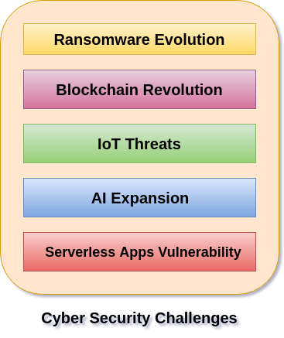

Ransomware is Getting Sneakier (Ransomware Evolution)
What it is:
Imagine someone locks all your important files (like photos, documents) on your computer and demands money (a "ransom") to unlock them. That's ransomware.
The Challenge:
Hackers are making newer, smarter versions of this digital lock. These are harder to detect and often steal your data before locking it. Then they threaten to leak your data unless you pay. It’s like a thief inventing new tricks and pressure tactics every time.

Blockchain: A New Playground for Bad Guys? (Blockchain Revolution)
What it is:
Blockchain is a super-secure shared digital ledger (like a record book) that’s famous for things like Bitcoin. It’s hard to change and widely trusted.
The Challenge:
While blockchain is secure, new apps built on it (like digital wallets, supply chain trackers) may not be. If these apps have weak security or are used for illegal purposes, they create new cybersecurity problems. It’s like building a secure vault but leaving the key in plain sight.

Smart Devices are Easy Targets (IoT Threats)
What it is:
IoT stands for Internet of Things — smart TVs, fridges, security cameras, even light bulbs that connect to the internet.
The Challenge:
Many smart devices have weak security — default passwords like "12345" or no updates at all. Hackers can easily break into them and use them for spying or launching bigger attacks. It’s like having lots of open windows in your house with no locks.

AI: Both a Friend and an Enemy (AI Expansion)
What it is:
AI (Artificial Intelligence) is when computers learn and do tasks that usually need human thinking — like detecting threats, answering questions, etc.
The Challenge:
- Bad AI: Hackers use AI to create fake but realistic emails, smart viruses, and automated attacks.
- Vulnerable AI: AI tools can also be tricked or hacked, leading them to make dangerous or wrong decisions.
It’s a powerful tool that can help or hurt — and sometimes the tool itself becomes the problem.

"No-Server" Apps Still Have Weaknesses (Serverless Apps Vulnerability)
What it is:
Serverless apps let developers run code without managing servers — the cloud provider does it. You just write small code functions that run when needed.
The Challenge:
Even though you’re not managing the servers, your code can still have bugs or security holes. If not configured properly, hackers can exploit it. It’s like a house without a front door, but still full of small open windows hackers can crawl through.

Issues of Cybersecurity with Details and Tips
- Data Breaches
When hackers gain unauthorized access to sensitive data like personal info, credit card numbers, or trade secrets.
Impact: Identity theft, financial loss, reputational damage.
Protection Tips:
  - Use encryption for sensitive data
  - Implement strong access controls
  - Regularly monitor systems for suspicious activity
- Malware
Malicious software including viruses, worms, ransomware, spyware, and trojans designed to damage or hijack your system.
Impact: Data loss, system crashes, ransom demands.
Protection Tips:
  - Install and update antivirus software
  - Avoid downloading files from untrusted sources
  - Keep your operating system and apps updated
- Phishing
Scammers send fake emails or create fraudulent websites to steal login credentials or financial info.
Impact: Account takeover, fraud, data leaks.
Protection Tips:
  - Don’t click on suspicious links
  - Verify sender email addresses
  - Use multi-factor authentication (MFA)
- DDoS Attacks
Attackers flood a network or website with massive traffic to overwhelm and shut it down.
Impact: Website downtime, lost revenue, damage to brand trust.
Protection Tips:
  - Use DDoS protection services (e.g., Cloudflare)
  - Monitor traffic patterns for anomalies
  - Have an incident response plan ready
- Weak Passwords
Passwords that are simple, reused, or easily guessable make it easier for attackers to break in.
Impact: Unauthorized account access and data theft.
Protection Tips:
  - Use strong, unique passwords (long, mix of characters)
  - Use a password manager
  - Change passwords regularly
- IoT Vulnerabilities
Connected devices (smart cameras, thermostats, etc.) often lack strong security, exposing your network.
Impact: Entry points for attackers, data leakage, network compromise.
Protection Tips:
  - Change default device passwords
  - Regularly update device firmware
  - Segment IoT devices on a separate network
- Insider Threats
Employees or contractors who intentionally or accidentally cause harm by leaking data or compromising security.
Impact: Data leaks, sabotage, compliance violations.
Protection Tips:
  - Implement strict access controls
  - Conduct employee security training
  - Monitor user behavior for anomalies

